Diffuse Reflection

📘 Definition
# Source: AI Source: Provided by: [Data Path: Persons Table -> ID Column: 1, Name_En Column: Motasem Essam] -> From: [ChatGPT] on [5/2/2026]
Diffuse reflection is a type of reflection where light hits a rough surface and scatters in many directions instead of bouncing in one clear direction.
Because of this scattering, you cannot see a clear mirror image, but the surface is still visible.

🌫️ How diffuse reflection works
# Source: AI Source: Provided by: [Data Path: Persons Table -> ID Column: 1, Name_En Column: Motasem Essam] -> From: [ChatGPT] on [5/2/2026]
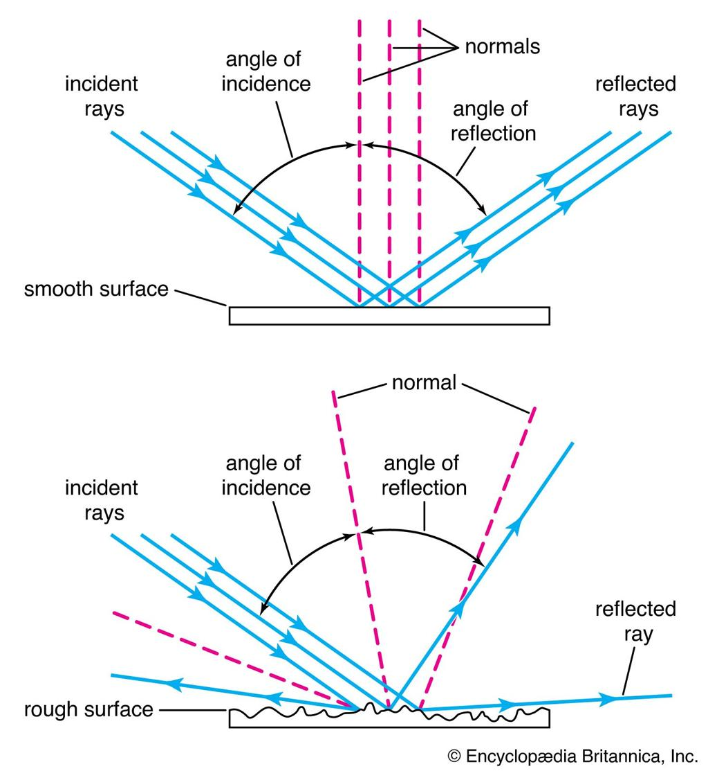
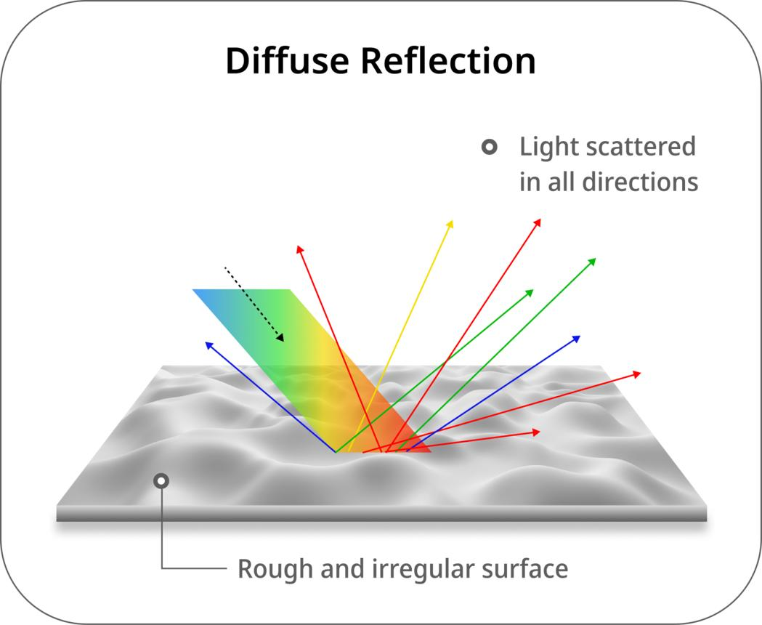
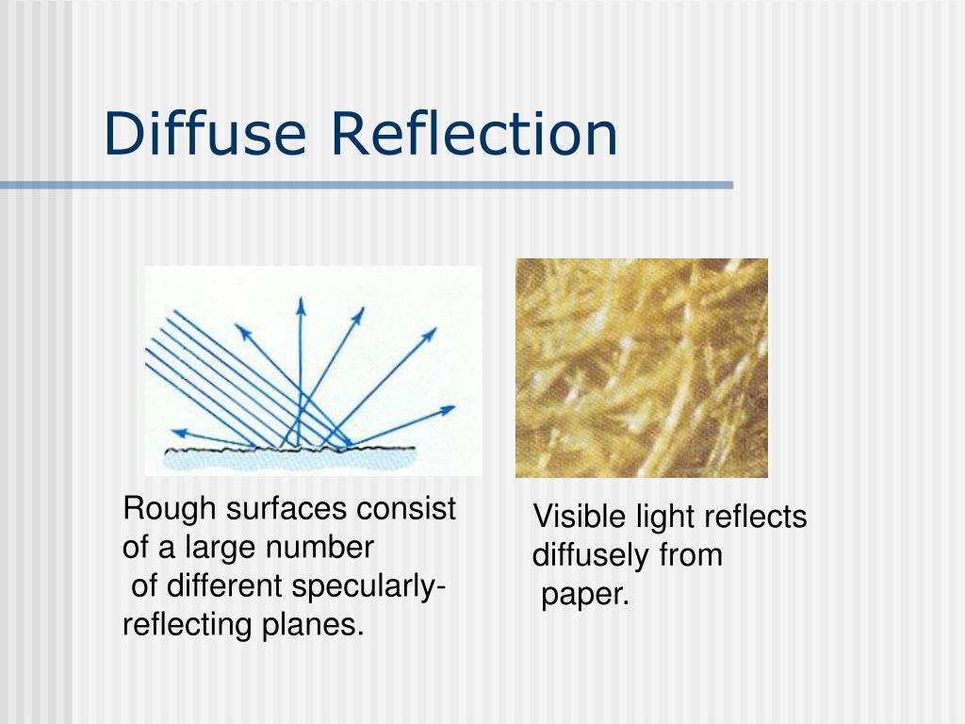
- Light hits a rough or uneven surface
- It bounces off in many directions
- No clear image is formed
- The surface still appears evenly lit

🧠 Simple example
# Source: AI Source: Provided by: [Data Path: Persons Table -> ID Column: 1, Name_En Column: Motasem Essam] -> From: [ChatGPT] on [5/2/2026]
Think of:
- 📄 Paper → you can see it clearly, but no reflection
- 🧱 Brick wall → light spreads in all directions
- 👕 Cloth → no shiny reflection, but still visible

🎮 In computer graphics
# Source: AI Source: Provided by: [Data Path: Persons Table -> ID Column: 1, Name_En Column: Motasem Essam] -> From: [ChatGPT] on [5/2/2026]
Diffuse reflection is used to:
- Make objects look natural and non-shiny
- Show realistic matte materials (skin, fabric, wood)
- Help lighting spread evenly across surfaces

⚙️ Key features
# Source: AI Source: Provided by: [Data Path: Persons Table -> ID Column: 1, Name_En Column: Motasem Essam] -> From: [ChatGPT] on [5/2/2026]
- 🌫️ Light is scattered in many directions
- 🚫 No clear or sharp reflection
- 🧱 Happens on rough surfaces
- 🎨 Gives objects a matte (non-shiny) look

🚀 In short:
# Source: AI Source: Provided by: [Data Path: Persons Table -> ID Column: 1, Name_En Column: Motasem Essam] -> From: [ChatGPT] on [5/2/2026]
Diffuse Reflection = light scattered in many directions from a rough surface, producing no clear reflection.

